Date:

# EXPERIMENT NO. 1

#### AIM: Implement a circuit in logisim to display given decimal number in binary on to seven segment display.

**TASK: i. display 0 to 9 on a seven segment display with binary number as input**

**ii. display 0 to 99 using two seven segment displays with binary number as input**

**TABLES OF CALCULATIONS:**

1. **display 0 to 9 on a seven segment display with binary number as input**

|  |  |  |  |  |  |  |  |  |  |  |  |
| --- | --- | --- | --- | --- | --- | --- | --- | --- | --- | --- | --- |
|  |  |  |  |  |  |  |  |  |  |  |  |
|  |  |  |  |  |  |  |  |  |  |  |  |
|  |  |  |  |  |  |  |  |  |  |  |  |
|  |  |  |  |  |  |  |  |  |  |  |  |
|  |  |  |  |  |  |  |  |  |  |  |  |
|  |  |  |  |  |  |  |  |  |  |  |  |
|  |  |  |  |  |  |  |  |  |  |  |  |
|  |  |  |  |  |  |  |  |  |  |  |  |
|  |  |  |  |  |  |  |  |  |  |  |  |
|  |  |  |  |  |  |  |  |  |  |  |  |
|  |  |  |  |  |  |  |  |  |  |  |  |
|  |  |  |  |  |  |  |  |  |  |  |  |
|  |  |  |  |  |  |  |  |  |  |  |  |
|  |  |  |  |  |  |  |  |  |  |  |  |
|  |  |  |  |  |  |  |  |  |  |  |  |
|  |  |  |  |  |  |  |  |  |  |  |  |

1. **display 0 to 99 using two seven segment displays with binary number as input**

|  |  |  |  |  |  |  |  |  |  |  |  |  |  |  |
| --- | --- | --- | --- | --- | --- | --- | --- | --- | --- | --- | --- | --- | --- | --- |
|  |  |  |  |  |  |  |  |  |  |  |  |  |  |  |
|  |  |  |  |  |  |  |  |  |  |  |  |  |  |  |
|  |  |  |  |  |  |  |  |  |  |  |  |  |  |  |
|  |  |  |  |  |  |  |  |  |  |  |  |  |  |  |
|  |  |  |  |  |  |  |  |  |  |  |  |  |  |  |
|  |  |  |  |  |  |  |  |  |  |  |  |  |  |  |
|  |  |  |  |  |  |  |  |  |  |  |  |  |  |  |
|  |  |  |  |  |  |  |  |  |  |  |  |  |  |  |
|  |  |  |  |  |  |  |  |  |  |  |  |  |  |  |
|  |  |  |  |  |  |  |  |  |  |  |  |  |  |  |
|  |  |  |  |  |  |  |  |  |  |  |  |  |  |  |
|  |  |  |  |  |  |  |  |  |  |  |  |  |  |  |

**CIRCUITS:**

**Binary To Bcd**

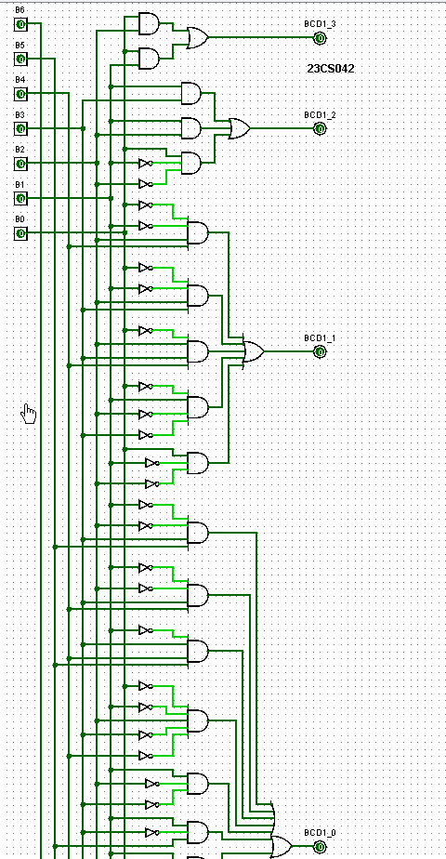

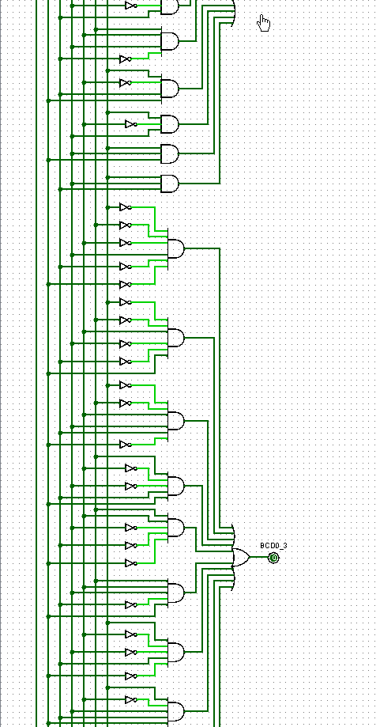

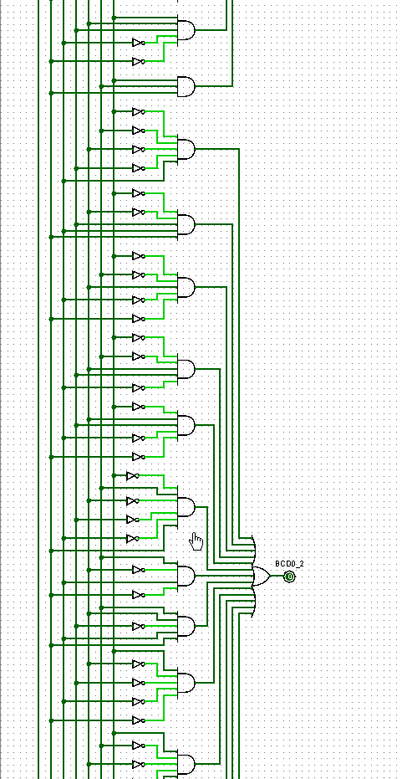



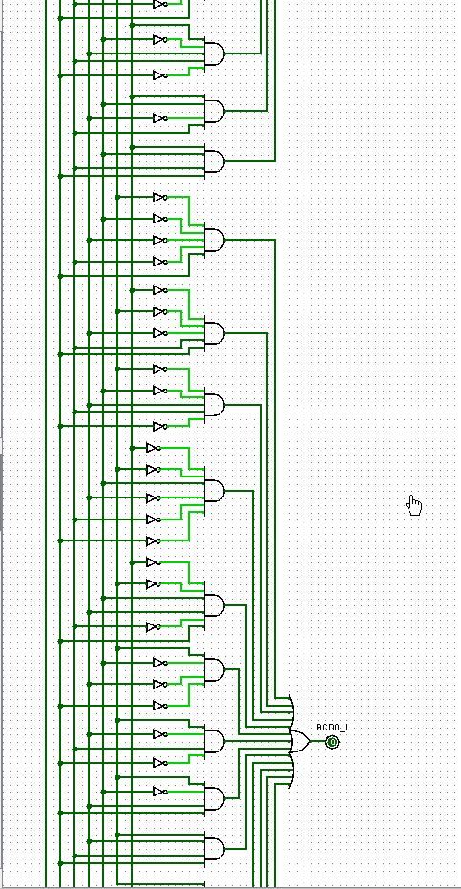



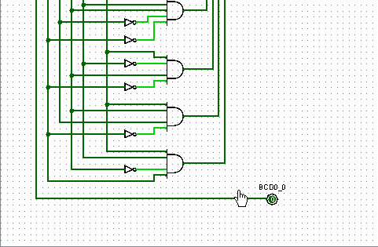

**Binary To 7 Segement**

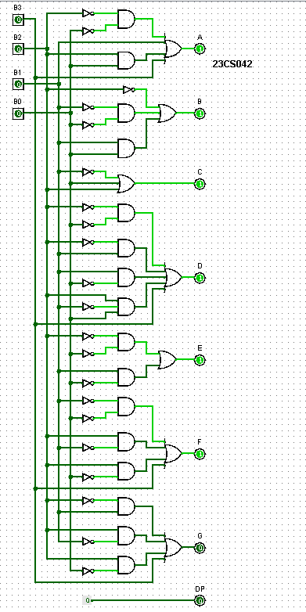

**OUTPUTS:**

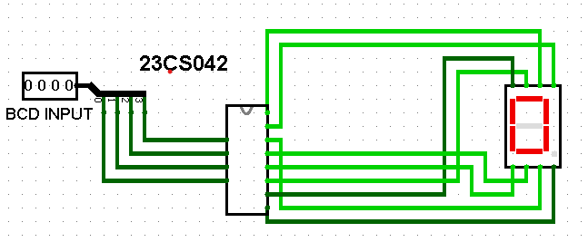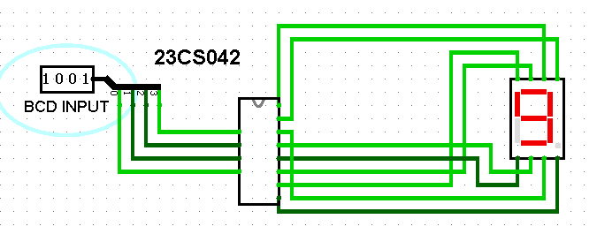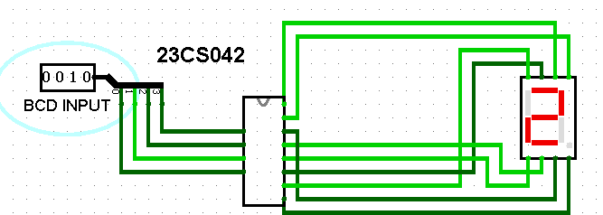

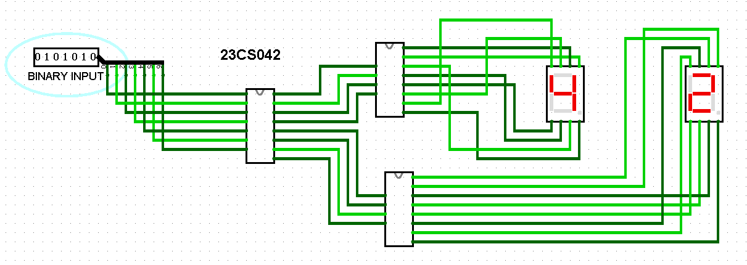

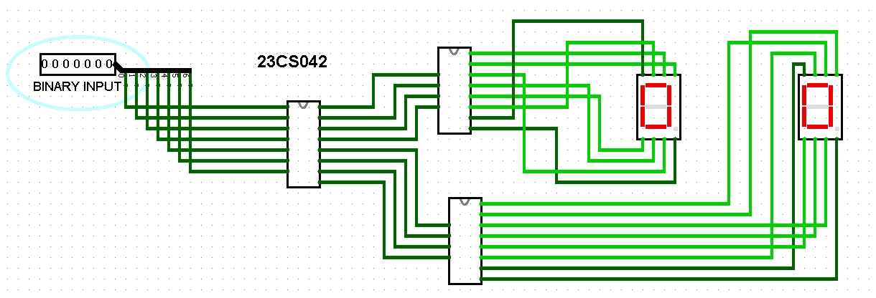

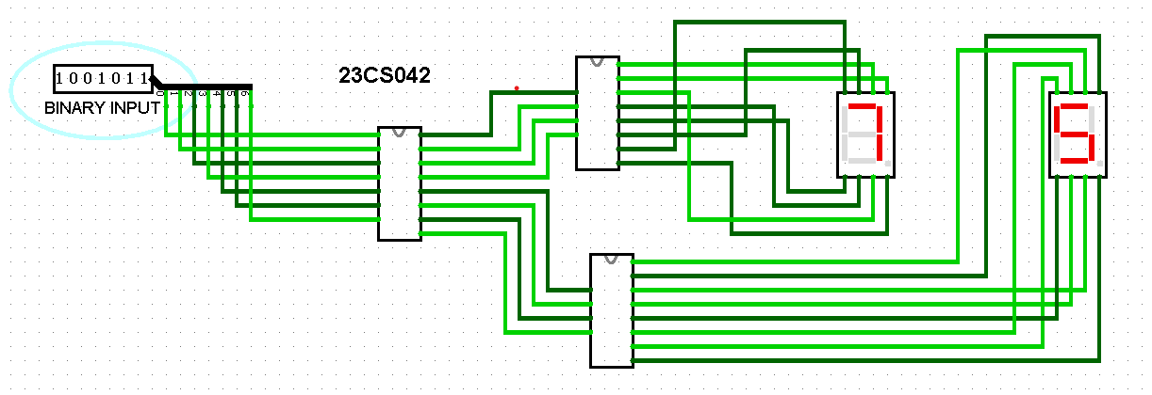

**CONCLUSION:**